4-bit Adder
Input 1 | Input 2 | Output
0101 | 0000 | 00101
0101 | 0001 | 00110
0101 | 0010 | 00111
0101 | 0011 | 01000
0101 | 0100 | 01001
0101 | 0101 | 01010
0101 | 0110 | 01011
0101 | 0111 | 01100
0101 | 1000 | 01101
0101 | 1001 | 01110
0101 | 1010 | 01111
0101 | 1011 | 10000
0101 | 1100 | 10001
0101 | 1101 | 10010
0101 | 1110 | 10011
0101 | 1111 | 10100

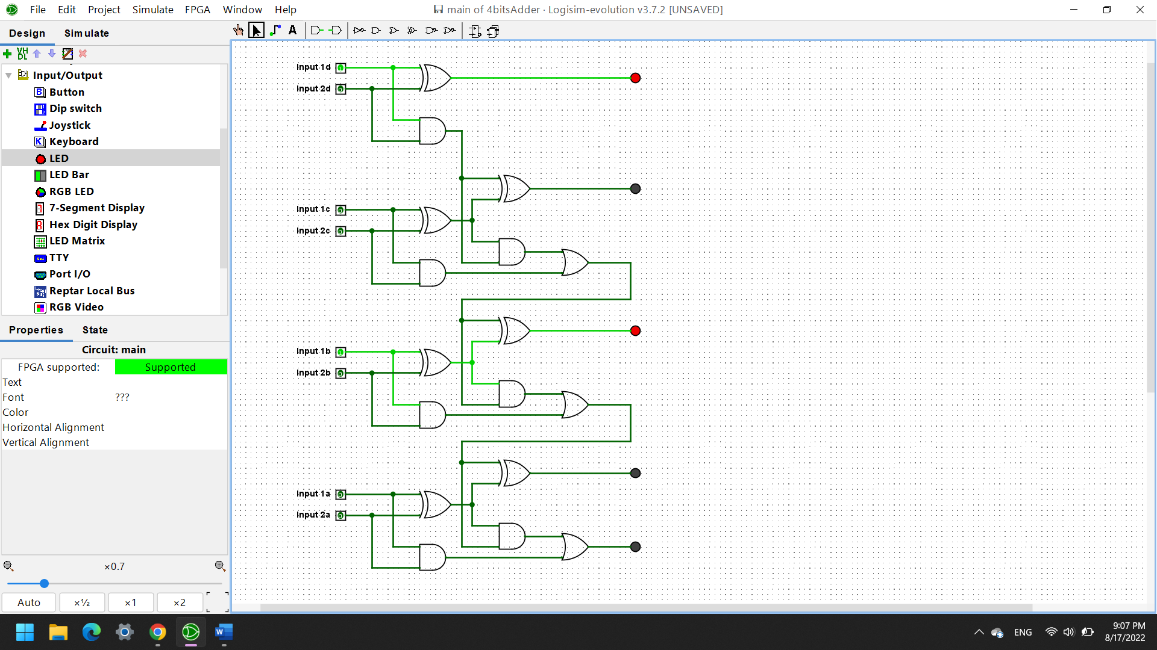
RS FLIP FLOP
Set | Reset | Q | Q’
1 | 0 | 0 | 1
1 | 1 | 0 | 0
0 | 1 | 1 | 0
1 | 1 | 0 | 0
When only one of the inputs (Set or Reset) is 1 (but not both), the state of Q or Q’ change into 1:
- If Set = 1 and Reset = 0, then Q’ = 1;
- If Set = 0 and Reset = 1, then Q = 1.
- The RS Flip Flop provides a easy way for memory to build up 1-bit storage units.
The RS Flip Flop holds 1 bit, while we set what it is to remember, and it retains this until we manually change it or the power go off.

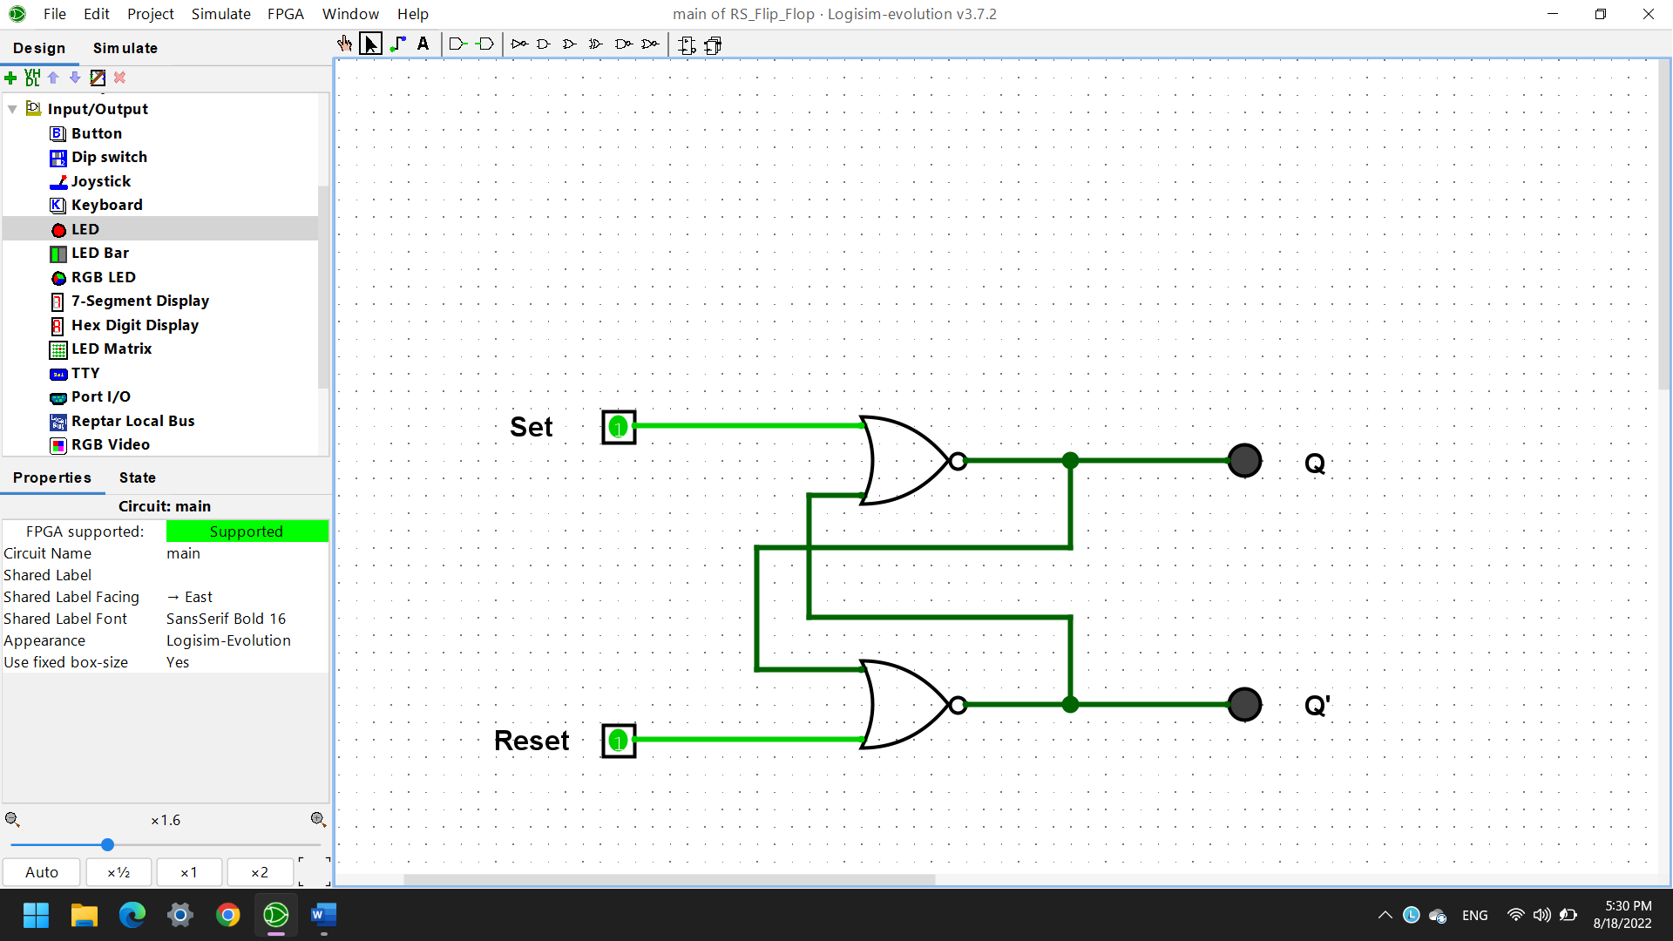

D Flip Flop
Clock | Pin | Q | Q’
0 | 0 | 0 | 0
0 | 1 | 0 | 0
1 | 1 | 1 | 0
1 | 0 | 0 | 1
The D Flip Flop only requires 1 input, when the clock is active, Q is upgraded to be just like D.
The D input generates both Reset and Set inputs. These are complements so never get both being active at once. The D Flip flop stores and output whatever logic level is applied to its data terminal so long as the clock input is high.
The clock’s role is to synchronize the signal of the input, it affects the change of input data.
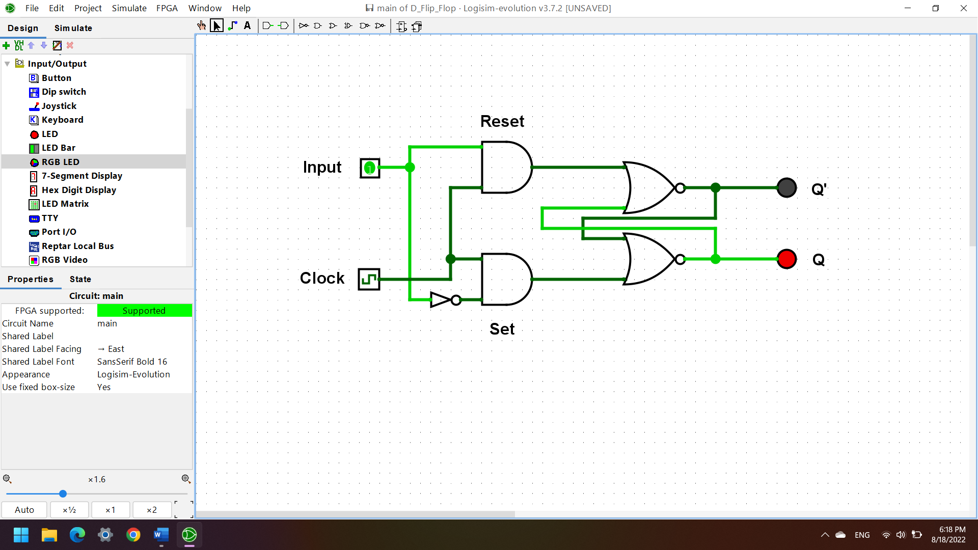
(N means at the clock, N+1 means after the clock)
D_{N} | D_{N+1}
0 | 0
1 | 1
The D Flip Flop is preferred than the RS one because it built up from a gated RS Flip Flop, with an inverter added between, which keeps the Set and Reset inputs away from being equal to one at the same time.

JK Flip Flop
J | K | Q (when clocked) | Q’ (when cloaked)
0 | 0 | No change | No change
1 | 0 | 1 | 0
0 | 1 | 0 | 1
1 | 1 | Toggle | Toggle

JK Flip Flop can be converted into a D one by driving its J and K inputs pins with the D input and the required additional hardware component would be a NOT gate.
D | Q_{N} | Q_{N+1}
0 | 0 | 0
0 | 1 | 0
1 | 0 | 1
1 | 1 | 1

JK Flip Flop can be made to behave like a toggle when both J and K inputs are 1.

